**Referential Integrity Constraint Violation/Anomalies**

An anomaly is an irregularity, or something which deviates from the expected or normal state. When designing databases, we identify three types of anomalies: Insert, Update and Delete.

**STUDENT (Referencing Relation)**

**ROLL_NO NAME ADDRESS PHONE AGE BRANCH_CODE**

1 RAM DELHI 9455123451 18 CS

2 RAMESH GURGAON 9652431543 18 CS

3 SUJIT ROHTAK 9156253131 20 ECE

4 SURESH DELHI 18 IT

**BRANCH (Referenced Relation)**

**BRANCH_CODE BRANCH_NAME**

CS COMPUTER SCIENCE

IT INFORMATION TECHNOLOGY

ECE ELECTRONICS AND COMMUNICATION ENGINEERING

CE CIVIL ENGINEERING

There are following three possible causes of violation of referential integrity constraint-

Cause-01: Insertion in a referencing relation

Cause-02: Deletion from a referenced relation

Cause-03: Updation in a referenced relation

* **Insertion Anomaly in Referencing Relation:**
* It is allowed to insert only those values in the referencing attribute which are already present in the value of the referenced attribute.
* Inserting a value in the referencing attribute which is not present in the value of the referenced attribute violates the referential integrity constraint.

We can’t insert a row in REFERENCING RELATION if referencing attribute’s value is not present in referenced attribute value. e.g.; Insertion of a student with BRANCH_CODE ‘ME’ in STUDENT relation will result in error because ‘ME’ is not present in BRANCH_CODE of BRANCH.

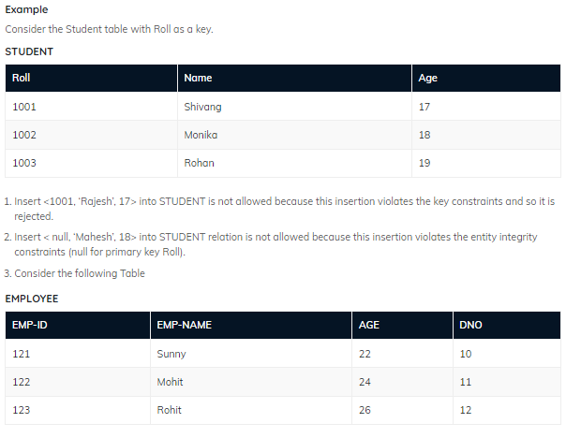

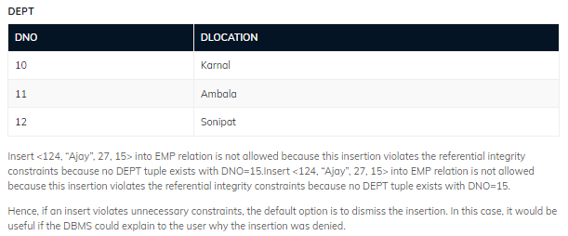

* **Deletion/ Updation Anomaly in Referenced Relation:**
* It is not allowed to delete a row from the referenced relation if the referencing attribute uses the value of the referenced attribute of that row. Such a deletion violates the referential integrity constraint.
* It is not allowed to update a row of the referenced relation if the referencing attribute uses the value of the referenced attribute of that row. Such an updation violates the referential integrity constraint.

We can’t delete or update a row from REFERENCED RELATION if value of REFERENCED ATTRIBUTE is used in value of REFERENCING ATTRIBUTE. e.g; if we try to delete tuple from BRANCH having BRANCH_CODE ‘CS’, it will result in error because ‘CS’ is referenced by BRANCH_CODE of STUDENT, but if we try to delete the row from BRANCH with BRANCH_CODE CE, it will be deleted as the value is not been used by referencing relation. It can be handled by following method:

**Handling the Violation-**

The violation caused due to a deletion from the referenced relation can be handled in the following three ways-

**Method-01:**

* This method involves simultaneously deleting those tuples from the referencing relation where the referencing attribute uses the value of referenced attribute being deleted.
* This method of handling the violation is called as On Delete Cascade.

**Method-02:**

This method involves aborting or deleting the request for a deletion from the referenced relation if the value is used by the referencing relation.

**Method-03:**

This method involves setting the value being deleted from the referenced relation to NULL or some other value in the referencing relation if the referencing attribute uses that value.

**ON DELETE CASCADE/** **UPDATE SET NULL:** It will delete the tuples from REFERENCING RELATION if value used by REFERENCING ATTRIBUTE is deleted from REFERENCED RELATION. e.g; if we delete a row from BRANCH with BRANCH_CODE ‘CS’, the rows in STUDENT relation with BRANCH_CODE CS (ROLL_NO 1 and 2 in this case) will be deleted.

**Handling the Violation-**

The violation caused due to an updation in the referenced relation can be handled in the following three ways-

**Method-01:**

* This method involves simultaneously updating those tuples of the referencing relation where the referencing attribute uses the referenced attribute value being updated.
* This method of handling the violation is called as On Update Cascade.

**Method-02:**

This method involves aborting or deleting the request for an updation of the referenced relation if the value is used by the referencing relation.

**Method-03:**

This method involves setting the value being updated in the referenced relation to NULL or some other value in the referencing relation if the referencing attribute uses that value.

**ON DELETE/UPDATE CASCADE:** It will update the REFERENCING ATTRIBUTE in REFERENCING RELATION if attribute value used by REFERENCING ATTRIBUTE is updated in REFERENCED RELATION. e.g;, if we update a row from BRANCH with BRANCH_CODE ‘CS’ to ‘CSE’, the rows in STUDENT relation with BRANCH_CODE CS (ROLL_NO 1 and 2 in this case) will be updated with BRANCH_CODE ‘CSE’.

